Monday 16th December | Tuesday 17th December | Wednesday 18th December | Thursday 19th December | Friday 20th December
Incursion | Incursion | Excursion | Incursion | Excursion
Wilbur’s Wildlife | Christmas Plaster Painting | Paradise Hotel | Pot Plant Painting & Planting | Movies
We are looking forward to seeing the native Australian animals!  Please be at OSHC by 10:15 am for the show. | Lots of Christmas crafts including plaster money boxes. | Children will need to bring $10.00 for lunch.  We will be walking, if the weather is too hot, we will travel in private cars. | Make some one you love a sweet gift or keep it for yourself! | We are very excited to be going to the movies.  No money please.  We will travel by private bus.  Please arrive by 8:45 am.
The Paradise for Kids Educators hope you all have a wonderful, Merry Christmas.
May 2020 be all you want and more!
Monday 6th January | Tuesday 7th January | Wednesday 8th January | Thursday 9th January | Friday 10th January
Home Day | Home Day | Excursion | Home Day | Incursion
Games Day | Water Play Day | Adelaide Museum | Wheels Day | Build Your Own Bear
Welcome back to 2020!  Kicking the year off with a great day of board games and electronics. | Bring a towel and bathers for a fun-filled day of water play and games. | 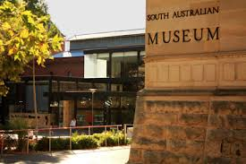  The children will spend a few hours exploring the wonders of the museum.  We will travel by private bus.  Please arrive by 9:45 am. | Please bring your wheels and helmet.  If the weather is super-hot, we will ride in the gym. | Today the children will build their own bears and fill them with love!

Monday 13th January | Tuesday 14th January | Wednesday 15th January | Thursday 16th January | Friday 17th January
Incursion | Incursion | Incursion | Excursion | Home Day
Babushka Doll Painting | Mini Golf | Radical Obstacle Course | Botanical Gardens | Pyjamas, pizza & Pixar
Today the children will be creating their own set of Babushka dolls. | In a Paradise for Kids first, Little Para Golf are bringing their mini golf course to us!  Experience begins at 12:30 pm. | 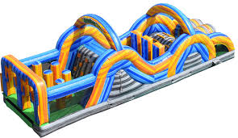  An amazing inflatable jumping obstacle course, the children will be worn out today! | We will go for a beautiful walk through the Botanical Gardens.  No money please.  We will travel by private bus.  Please arrive by 8:45 am. | Chill out on this p.j. day as we have a pizza snack and watch Pixar movies throughout the day.

Monday 20th January | Tuesday 21st January | Wednesday 22nd January | Thursday 23rd January | Friday 24th January
Incursion | Incursion | Incursion | Excursion | Excursion
Clay Art/  Messy Day | Fire & Ice Science Show | Water Slide | Mega Courts | Movies
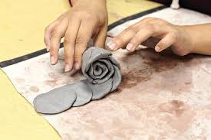  Get creative with fun coloured clay.  Bring a change of clothes for some messy play too! | 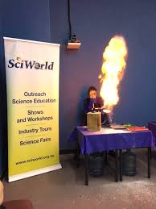  In another Paradise for Kids first we have SciWorld are coming and bringing their 90-minute science show about Fire & Ice.  This will be a visual spectacular. | Bring bathers and a towel for this epic day of fun.  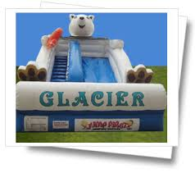 | We are off to the mega-inflatable fun zone, with jumping castles, mazes, basketball and soccer.  No money please.  We will travel by private bus.  Please arrive by 9:00 am. | Last day of the holidays, we will celebrate going to the movies one last time! No money please.  We will travel by private bus.  Please arrive by 8:45 am.
Our programs are based on the “My Time, Our Place” framework for school aged care in Australia.
Bookings
- Booking sheets provide consent for activities and must be signed every day your child/ren is attending.
- Overdue fees must be paid before vacation care bookings are accepted.
Fees
- The set fee for Vacation Care is $65.00 per day.
- These fees will be less the Child Care Subsidy in accordance to your eligibility.
- Invoices will be sent weekly following your child’s attendance at the service via email unless otherwise specified.
- Payments can be made by EFT or in cash to one of the OSHC Educators or payments can be made to the School Front Office.
Cancellations
- As per our Fees Policy, 14 days’ notice is required to cancel care over the Vacation Care Period to avoid being charged an absent fee.
Hours
- 7:00 am- 6:00 pm. Please sign your children in and out daily.
- A fee of $1.00 per minute, per child applies after 6:00 pm regardless of how many children are still present.
- Educators will sign children out after 6:00 pm.
Food and Drinks:
- A drink bottle of water, healthy recess and lunch is required every day.
- Breakfast is provided before 8:00 am and Afternoon Snack is provided between 3:30 and 4:00 pm.
- No spending money is permitted on excursions unless it’s specified on the program.

Other information for families:
- Electronics brought from home can be used at times specified by educators. At all other times they will need to be put in children’s bags or in the electronics box.
- Electronics CAN NOT be recharged at OSHC.
- Please note: Children’s belongings cannot be stored in the staff office.
- Please ensure children bring a Sun Smart hat with them every day throughout the vacation care period.
- Please ensure children are dressed appropriately for the day’s experiences.
- OSHC Educators will not take responsibility for toys brought from home.
- Educator ratio of 1 adult:15 children is observed always. Additional staff will be provided when required for varying circumstances.
Child Surname: ____________________________
Child 1: __________________________________
Child 2: __________________________________
Child 3: __________________________________

Please record approximate drop off and pick up times.

Monday 16th December | Tuesday 17th December | Wednesday 18th December | Thursday 19th December | Friday 20th December
Incursion | Incursion | Excursion | Incursion | Excursion
Wilbur’s Wildlife | Christmas Plaster Painting | Paradise Hotel | Pot Plant Painting & Planting | Movies
am  pm | am  pm | am  pm | am  pm | am  pm
Sign | Sign | Sign | Sign | Sign
Monday 6th January | Tuesday 7th January | Wednesday 8th January | Thursday 9th January | Friday 10th January
Home Day | Home Day | Excursion | Home Day | Incursion
Games Day | Water Play Day | Adelaide Museum | Wheels Day | Build Your Own Bear
am  pm | am  pm | am  pm | am  pm | am  pm
Sign | Sign | Sign | Sign | Sign
Monday 13th January | Tuesday 14th January | Wednesday 15th January | Thursday 16th January | Friday 17th January
Incursion | Incursion | Incursion | Excursion | Home Day
Babushka Doll Painting | Mini Golf | Radical Obstacle Course | Botanical Gardens | Pyjamas, pizza & Pixar
am  pm | am  pm | am  pm | am  pm | am  pm
Sign | Sign | Sign | Sign | Sign
Monday 20th January | Tuesday 21st January | Wednesday 22nd January | Thursday 23rd January | Friday 24th January
Incursion | Incursion | Incursion | Excursion | Excursion
Clay Art | Fire & Ice Science Show | Water Slide | Mega Courts | Movies
am  pm | am  pm | am  pm | am  pm | am  pm
Sign | Sign | Sign | Sign | Sign

Conditions
- I agree to pay any and all fees incurred by this vacation care program within two weeks of receiving each invoice.
- As per booking and cancellation policy, cancellations made without 14 days’ notice will be charged at full fee.
- If accepted, bookings made on the day will incur the casual fee (as per booking and cancellation policy).
- Failure to arrive on time on excursion days will result in a non-attendance being recorded and that my account will be billed.
- I understand that the vacation care fee is $65.00 per day.
- By signing, I give permission for my child/ children to attend and participate in the activities advertised in the Paradise for Kids Vacation Care Program and all planned daily activities.
- Excursion destinations and travel methods are indicated on the program.
- All programmed experiences have been subject to a formal risk assessment.
- Children and Educators may go for walks on any of the vacation care days.

I agree to all the conditions listed above:
Parent’s/ Guardian’s Name________________________________________
Signature_______________________________________ Date__________

