Welcome to Paradise for Kids, please read the following information carefully!
School holidays are just a few weeks away!!! Paradise for Kids provides a fun-filled vacation care program during the term breaks. Families who use our service regularly know that places fill fast, and early booking is essential.

Who Can Come?
Vacation Care is open to school age children, 4.7 – 15 yrs. Eligible children from all schools, childcares or kindys are welcome to attend.

Enrolment Details:
If it is your first time using the service you will need to complete an enrolment form and be entered into our system before your Vacation Care bookings can be accepted.
Please make sure all your contact details and emergency contacts are up-to-date. If you are unsure, we can send you an enrolment update detailing the current information associated with your account.

Opening Times and Dates

Please see the Vacation Care Program and Booking sheets for service dates. The program will also detail any public holiday or service closure dates that may fall in that period.

Our Hours are 7:00am – 6:00pm. A fee of $1 per minute per child applies for any pick-ups after 6:00pm.

Please note the service is closed on Public Holidays and between the Christmas – New Year period.

Fees and Childcare Benefit/Rebate:
 | Booking Sheet Returned | Late Notice Booking
Vacation Care | $49 | $54
Vacation Care incursion/ Excursion | $55 | $60

Sessions booked in advance (i.e. before the end of term on a returned booking sheet) are $49 for a “Home” day and $55 for an incursion/ excursion day.
Sessions booked after the last day of term or on the day are charged at the casual rate of $54 for a “Home” day and $60 for an incursion/ excursion day.
Non-attendance of a booked session without 14 days notice will be billed the full fee.
Eligible families are able to claim CCB and CCR to reduce their session fees.
To be eligible for your childcare rebate, you MUST register for care, even if you intend to pay full fees. You can do this by phoning the Family Assistance Office on 13 61 50 and ask to be assessed for Child Care Benefit, (CCB).
As our service offers over 50 hours of care per week, (and the maximum eligible hours of CCB are 50), families who book 5 days per week will be charged a higher rate for the 5th booking.

Accounts with Paradise 4 Kids
All outstanding accounts must be cleared before bookings for Vacation Care are accepted. All vacation care accounts must be finalised within two weeks of receiving the invoice. We accept cash and cheques made to Paradise Primary School.
EFT payments can be made into the Paradise Primary School Council Account via your online Banking institution website our details are:-
BSB – 105 152
ACC # 039 198 340
Please ensure the service has a valid e-mail address to send accounts to.

Bookings for Vacation Care:
To book your child/ren, please complete the booking form provided. Be sure to include your anticipated arrival and departure times, as well as ensuring all relevant permission sections are signed. You can return your completed form to OSHC or the front office.
To comply with licensing and quality standards, children MUST be signed in on arrival, and signed out upon pick up, by an authorized adult.
Waiting Lists and Priority Access Guidelines
In the event that a session becomes booked out and a waiting list is kept, Paradise for Kids follows the Commonwealth Government Priority of Access Guidelines in allocating any places that become available. The categories are listed below:
Priority 1—a child at risk of serious abuse or neglect,
Priority 2—a child of a single parent who satisfies, or of parents who both satisfy, the work, training, study test under section 14 of the A New Tax System (Family Assistance) Act 1999,
Priority 3—any other child.
Working families who are categorised as Priority 3 are encouraged to book as soon as you are able for the best chance of securing a booking.

What to Pack:
Each day children are required to bring
Recess, lunch, drink bottle (water only), Sun Smart hat
Our service provides breakfast, afternoon tea and fresh drinking water. We recommend a healthy lunchbox be packed each day. This may include fresh fruit, yoghurts, fresh cooked popcorn, rice cakes, salads, whole meal wraps and sandwiches. To keep your food fresh we have a fridge available. We also have a microwave available for re-heating. If you do not provide lunch you will be billed for the food provided by us.
Medication:
If your child requires medication, please see staff to ensure an up-to-date health care plan is completed. All medication must be given to a staff member on arrival. Children over eight are expected to be able to administer their own asthma medication.
Don’t forget to put your child’s name on everything!

Snack and meal times:
If your child/ren requires breakfast, please let a staff member know upon arrival.
Afternoon tea is intended as a snack only and is not intended to replace your child’s dinner. During Vacation Care, children often use extra energy playing and therefore we suggest you pack more food than you would for a typical school day.
On excursion days, please pack non-perishable foods that DO NOT need re-heating or cooking.
On excursion days we are unable to ensure the ability to re-heat food (this includes 2 minute noodles).
Please do not pack chocolate bars
We are a healthy eating service as well as being allergy aware. Chocolate bars can often melt while in lunch boxes and affect other food.

Toys, Games and Electronics from Home:
Children can bring their Nintendo DS, PSP, MP3 players, iPod’s, or any other electronic music or gaming devices to Vacation Care. Children are also welcome to bring DVD’s and other electronic games that are rated G.
However, children who bring any personal toys, games and equipment from home do so at their own risk, and are responsible for their own property. Paradise 4 Kids will NOT be liable for any damaged or lost property.
Continuous playing of PC and hand-held games is not encouraged. Several periods throughout the day are nominated as ‘technology free time’. During these times, all electronic devices are switched off.

Children CAN NOT bring chargers for their equipment. Once the battery is flat, the item must be packed away.

Behavior Management
We have a no tolerance policy on deliberate aggressive, violent and abusive behaviour. If your child causes deliberate physical or emotional harm to a staff member or another child they will be sent home and may be suspended from care for up to 5 days.
Paradise 4 Kids ensures a friendly, safe and welcoming environment for all children and families. If you have any concerns regarding your child/ren’s attendance with us please do not hesitate to get in contact.
Please make sure you read the information about excursions, incursions and home days.
- Where not indicated on the program, daily activities include arts, craft, indoor and outdoor play will occur.
- To avoid excess charges at least 14 days’ notice must be given for all cancellations.
- A fee of $1 per minute will be charged per child after 6 pm collection time.
- Nonattendance of booked sessions will be billed at full fee.

Loved Vacation Care, now you’re looking for some care during the school term?

Fortunately, we also provide Before and After School Care, and we are open on Pupil Free Days!

Who We Are
The Paradise 4 Kids team are a group of dedicated educators with a wide range of qualifications and backgrounds, each bringing their own special talents and unique skills.

All of our staff maintain the necessary clearances and up to date certificates, such as
- First Aid Training
- Police Checks (DCSI Clearance)
- Reporting Abuse and Neglect Training (RAN)
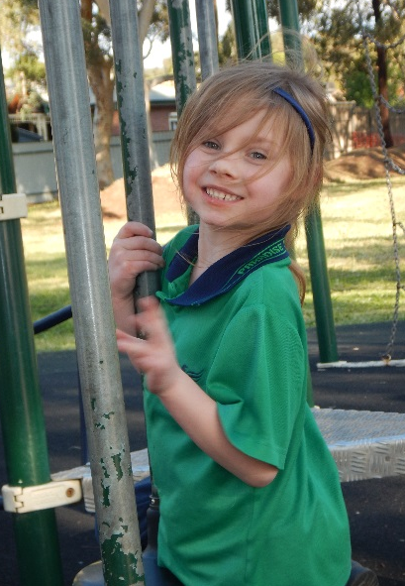
We are an Asthma Friendly and Allergy Aware service, as well as being recognised for our Sun Smart policies and practices.
We take the health and safety of the children in our care very seriously. Please see the Director if you have any concerns about your Child’s health while they are in our care.

Full Contact Details:
We can be found in the building directly in front of the
Paradise Primary School George St Carpark.

100 George St
Paradise, SA, 5075
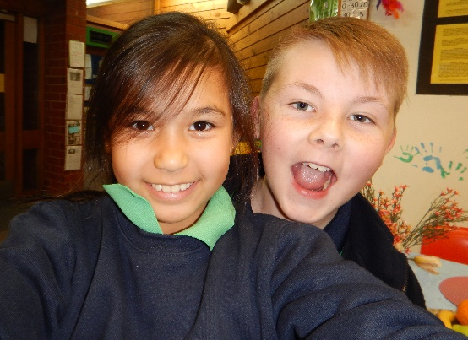
Phone | 08 7120 7186
Mobile | 0478 292 590
Email | paradiseforkids@internode.on.net
Web | www.paradiseforkids.net

